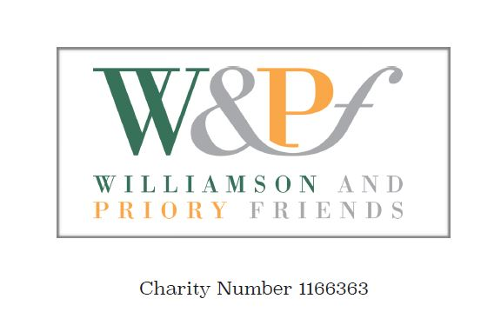
2022 Standing Order Form

TO BE SENT TO YOUR OWN BANK

The annual membership fee is £10 and Membership runs from January to December.
Members joining mid-year should renew in the following January.

Members joining in October, November or December are eligible for membership until the end of the following year.

Additional Donations are optional and of course very welcome to support our activities at the Williamson Art Gallery and Birkenhead Priory.

How to pay your subscription by Standing Order

Please make a payment now, with future payments on a date in January.

Payee account name: Williamson and Priory Friends

Sort code: 40 10 22 Account number: 42384523

Please give your Surname and Postcode as a reference and set this up with your bank.

TO BE SENT TO YOUR OWN BANK

